ESSENCE RESIDENCES

LEASEHOLD AGREEMENT OF CONDOMINIUM

THIS LEASE AGREEMENT (the “Agreement”) is made on … at 88/89 Moo2 Rawai Sub-district, Mueang Phuket District, Phuket.

BY AND BETWEEN:

Essence Residence Co., LTD., a company duly registered in Thailand with Company Registration Numbered 0835564006545 whose registered office is at 88/89 Moo 2,Tambon Rawai, Amphoe Mueang Phuket, Chang Wat Phuket Province Thailand, represented by Ms. Oranong Thongsiri as the authorized director (hereinafter referred to as the “Lessor”), whose fully detailed particulars appear in the Affidavit and authorized director’ ID card/ passport attached hereto and marked Exhibit A of the one part and

… (hereinafter referred to as the “Lessee”), whose fully detailed particulars appear in the ID card / passport attached hereto and marked Exhibit B.

WHEREAS:

- The Lessor is the developer of ESSENCE RESIDENCES (hereinafter referred to as the “Condominium Project”) located and will be constructed on the land designated by Land Title Deed Nor. Sor. 4 Jor. No 93863 Rawai Sub-District, Mueang District, Phuket Province, aggregated area of approximately 2 Rai - 1 Ngan Square Wah or approximately 3,869.5 Square Meters, (hereinafter referred to as the “Condominium Project Land”), attached hereto and marked Exhibit C.

- The Lessor agrees that when the construction of Condominium project is completed, the Lessor shall register it as the condominium in accordance with Thai law.

- The Lessor agrees to construct the 1 (One) Condominium project comprising upwards to 160 (one hundred sixty) condominium units located within 3 (Three) buildings, hereinafter referred to as the “Condominium”.

- The Lessor agrees to lease, and the Lessee agrees to accept a lease over condominium Leasehold unit number …, located at … floor, building …, with an approximately area including with balcony of … square meters (hereinafter referred to as the “Leasehold Unit”), whose fully detailed particulars appear in the Leasehold Unit plan, Floor plan, Master Plan, and specification attached hereto and marked Exhibit D, E.

NOW IT HEREBY AGREED as follows:

      - DEFINITION

  - The Agreement: means this Agreement and the Exhibits attached hereto, and includes any subsequent amendments made in accordance with its terms in the manner provided herein.

  - Leasehold Unit: means Condominium Leasehold unit number …, located at … floor, building …, with an approximately area including with balcony of %... square meters.

  - Condominium project: means Essence Residences Condominium project located in Rawai, Mueang, Phuket, comprising 160 (one hundred sixty) Units.

  - Condominium Act: means a building in that persons are able to divide ownership in the building in parts where each part comprises ownership in personal property and co-ownership in common property.

  - Co-owners: means the owners of the Condominium Units in the Condominium.

  - Condominium Project Land: means Land Title Deed Nor. Sor. 4 Jor. No 93863 Rawai Sub-District, Mueang District, Phuket Province, aggregated area of approximately 2 Rai – 1 Ngan Square Wah or approximately 3,869.5 Square Meters.

  - Private Property: means a Condominium Leasehold Unit and any construction registered on the property of the individual owner of that Condominium Leasehold Unit.

  - Common Property: means the completed driveways walkways, electrical systems, plumbing systems, gardens, swimming pool, office facilities, etc, and amenities provided by the Lessor, which is not individually owned by any Lessee.

  - Regulations: means the Regulations apply to Co-owners of Condominium Project.

  - Lease Registration Date: means the date on which the Parties registered the lease at the Phuket land office.

  - Completion Date: means the date on which the construction of the Leasehold Unit will be completed shall not be later than 30th of June 2026.

  - Rental price: means the cost to rent the Leasehold Unit for a period of initial 30 years including with all time periods of lease renewal of … THB (…Baht Only).

  - Lease Terms: means the term of 30 years commencing on the Registration Date.

  - Condominium Juristic Person (CJP): means the Juristic Person supervises, manages, resolves any issues and, is responsible for any works assigned by the CJP Committee, Co-owners, etc for the good order of the Condominium.

  - Sinking fund means: The Sinking Fund is the one-time payment payable by the Co-Owners to the Condominium Juristic Person as a reserve fund for repair or replacement of the Common Property and other management prescribed in the Regulations.

  - Common Area fee: means the amount of monies that each Co-Owner is responsible to pay to the Condominium Juristic Person as prescribed in the Regulations.

  - PP/SQM: means the number of differences of the excessed or deducted areas per square meters.

  - Establishment Date: means the date the CJP is completely registered with the Competent Authority.

  - Condominium Registration Date: means the date of registration of the Condominium.

- PURPOSE OF LEASE

The Lessee accepts to lease the Leasehold Unit for residential purposes only and hereby agrees not to use nor permit any other person to use the Leasehold Unit nor any part thereof permanently or temporarily for any other purpose without the express prior permission of the Lessor in writing.

- RENTAL PRICE

  - In consideration of the lease of Leasehold unit under this Agreement, the Lessee agrees to pay the Rental price of … THB (…Baht Only) (hereinafter referred as “Rental”) to the Lessor.
  - The Rental Price mentioned above includes the built-in furniture and the furniture package provided in Exhibit E.

The Lessor shall send the Lessee an invoice for payment not later than 14 (Fourteen) days before the payment date. The Lessee is obliged to make the payment not later than the date in accordance with the Payment Schedule specified in clause 4.

- PAYMENT SCHEDULE AND RENTAL PAYMENT

  - Payment Schedule:

1st Installment: The deposit of … (…Baht Only) has been paid to the Lessor on ….

2nd Installment: The sum of … (… Baht Only) shall be paid to the Lessor within ….

In making payment for the Leasehold Unit, the Lessee shall be made to the Lessor by telegraphic transfer to:

Account Name: Essence Residence Co., LTD
Bank: KASIKORN BANK PCL
Branch: HAYAKCHALONG PHUKET
Account Number: 166-8-481147
Swift Code: KASITHBK
Payment details: For the purchase of Leasehold unit No…, Essence Residences, on behalf of ….

  - Rental payment:

The Lessee may transfer the Rental fee or Purchase of the leasehold unit from off-shore into Thai bank account of the Lessor or the Lessor’s representative in any foreign currency without applying the conversion into Thai currency as stated in accordance with the Condominium Act. However, the money that the Lessee transfers into the account in Thailand after deducting the relevant fee must be not less than or equal to the Rental fee of the Leasehold Unit.

All bank charges in connection with the conversion of foreign currency into Thai Baht, as a result of inward remittance or transfer of funds, shall be borne solely by the Lessee.

It is the Lessee's responsibility to use the correct payment details description, as shown above, upon transferring the money from abroad in order to obtain the Foreign Exchange Transaction Form (FET) or the bank certificate stating the correct reason for payment. Once the Lessor receives the Rental price, the Lessor shall be responsible to prepare the bank certificate or other relevant documents for the Lease registration.

  - All cost and bank charges incurred to remit all payments under the Booking contract and this Agreement shall be paid by the payer. The amount credited to the recipient’s bank charges and/or exchange rate fluctuations shall be adjusted in the subsequent payment where applicable and subject to any such payment being within not more than two percent (2%) of the total amount due under each installment whereupon all such differences shall be settled collectively on payment of the final installment or payment as the case may be according to the Agreement.

  - In the event of any dispute between the parties regarding payments hereunder the copy of the original the remitting bank’s remittance order or/ and copy of e-receipt shall be accepted as proof of payment and the date the payment is discharged shall be the date the payment is credited to the recipient bank account of the thereof.

- COMPLETION DATE

  - The Lessor agrees that the construction of the Leasehold unit shall be completed within 30th of June 2026. (the “Completion date”).

In the case where it is necessary for the construction to be delayed or suspended by any event of the Force Majeure or events beyond the control of the Lessor, the Completion Date is to be extended no longer than one (1) year (the “Extension of Completion Date”). In such event, the Lessee agrees that the Lessor shall be entitled to extend the Completion Date by serving a written notice of such event on the Lessee within 30 (Thirty) days.

  - The Lessor represents and affirms that the Leasehold Unit and the Common Property shall be completely constructed in a good and workmanlike manner with materials and specifications in accordance with the Applicable Law or as set out herein.

  - In the case where the Registrable Area is less than the Saleable Area, the error may give the Lessee an entitlement to an adjustment of the purchase price for the difference in excess of 5 (five) percent of the Saleable Area (if any) calculated proportionally with the PP/SQM on such excess. The Lessee is entitled to deduct the Final Payment with the result from the adjustment; the balance in this case shall be the Final Payment under this Agreement. In the contrary, the Lessor shall have the same entitlement where the Registrable Area is more than the Saleable Area for the difference in excess of 5 (five) percent of the Saleable Are, in this case, the said calculation shall apply, mutatis mutandis and any increment of the purchase price shall be added with the Final Payment and shall be deemed the Final Payment hereunder.

- INSPECTION AND ACCEPTANCE OF THE LEASEHOLD UNIT

  - Upon the completion of Leasehold Unit, the Lessor shall inform the Lessee to conduct a physical inspection of the Leasehold Unit. The Lessee or its duly appointed representative must appear and conduct the inspection of the Leasehold Unit on the date specified by the Lessor (Inspection date). The Lessor must notify the Lesse of upcoming inspection 60 days before the inspection date.

  - If the Lessee fails to show up on the Inspection date for any reason, it shall be deemed that the Lessee agrees to accept the Leasehold unit immediately and the Lessee is still obligated to pay the Rental to the Lessor without resisting.

  - In case the Leasehold unit has defects or it is not complete according to the terms, conditions, and specifications of this Agreement, the Lessee shall notify the Lessor in writing with all details and send written notice specifying the description to the Lessor and The Lessor shall commence work to effect complete remedy, repair or new replacement immediately within 30 (thirty) days of receiving notice thereof from the Lessee.

The Parties acknowledge and agree that the defects of Leasehold units will not affect the Lease registration and the Lessee will not claim any costs of such defects.

- DEFECT LIABILITY

The Lessor shall resume defect liability which may incur due to defect of the Leasehold Unit in the following cases.

  - In the event of defects in the structural part of the Leasehold Unit, the liability period shall be 5 (Five) years from the moment of commissioning of the facility.

  - In the event of defects in the non-structural part of the Leasehold Unit, the liability period shall be 2 (Two) years from the moment of commissioning of the facility.

The Lessor shall remedy the defect incurred to the condominium within 30 days from the date that the Lessee or condominium juristic person, as the case may be, has notified in writing for such defect except in case where such defect needs urgent remedy which the Lessor has to commence immediately after being notified. If the Lessor fails to remedy such above-said defect, the Lessee or condominium juristic person, as the case may be, is entitled to make its own remedy or hire other person to do so for which the Lessor agrees to reimburse the damages or expenses for such defect remedy.

- CONDOMINIUM REGISTRATION DATE

The Lessor must register the condominium with the competent authority and obtain the title deed for the Condominium units under the Condominium Act within 12 (Twelve) months from the Completion date of the Leasehold unit and Common property or the extension period (the "Condominium Registration Date"), at their own cost and expense, and at any case after the Thai government releases the assessment unit price.

- ESTABLISHMENT OF THE CONDOMINIUM JURISTRIC PERSON (CJP).

The Lessor at their own cost and expense shall register the CJP with the Competent Authority and shall obtain its certificate within 30 (Thirty) days following the Condominium Registration Date. The Lessor shall be also responsible to prepare and register the Regulations with the Competent Authority at the time of such establishment of the CJP (“Establishment Date”).

It is clearly understood that the Condominium Registration Date and CJP Registration Dates can be set ONLY upon receiving relevant documents/information from competent Authorities therefore the Lessor is to be released from any liability in case of registration delays which are attributable to the Governmental Authorities.

- LEASE REGISTRATION, LEASE REGISTRATION COST AND LEASE TERM

  - When the construction of the Leasehold unit and all common areas of the condominium is completed and the Lessor has obtained the Condominium license or relevant permits accordingly and the Lessee has paid all Rental payments to the Lessee, the lease registration shall proceed at the Land Department within 12 (Twelve) months from the Establishment Date (the “Lease Registration Date”).

The Lessor shall notify the Lessee by giving 30 (Thirty) days in advance notice in order to register with the competent Land office and /or any other competent authority.

If the Lessee is unable to register the lease right on the Lease Registration Date by actual presence, the Lessee shall appoint an attorney or the Lessee’s representative to carry out the registration with the Lessor or its representative on the Lease Registration Date.

  - The Lessor agrees to grant a lease and the Lessee agrees to take on the lease of the Leasehold Unit for the period of 30 (Thirty) years commencing from the Lease Registration Date together with renewals for further 2 (Two) terms of 30 (Thirty) years each as prescribed herein (“Lease Term”).

  - The Lessor and the Lessee are equally responsible basis on a of 50-50% for all registration fees, all taxes, duty stamp fees, and other expenses incurred to the Lease Registration.

The 2 (Two) terms renewal of the Lease Term shall be solely paid by the Lessee.

  - The Lessee acknowledges that the Lessee shall be solely responsible to provide the bank certificate and/or other documents, in case a Competent Authority will require any documentation needed for the lease registration.

- OPTION TO PURCHASE

During the Lease term, the Lessee is entitled to upgrade the Leasehold unit to the Freehold unit under the terms and conditions below:

        - If the proportion of foreign ownership allowed by the Condominium Act is increased and/or a unit of the Condominium is available for Purchase.

  - If the Lessee is legally qualified to have ownership in accordance with the Condominium Act and any subsequent amendment thereto.

The Lessee needs to inform the Lessor of upgrading from Leasehold to Freehold unit 30 (thirty) days written notice in advance.

The Lessor agrees to proceed to register such conveyance of ownership of the Leasehold unit to the Lessee within 30 (thirty) days from the date of receiving written intention thereof from the Lessee. The Lessee shall be responsible for all taxes, stamp duties, and fees imposed by the relevant authorities for the Purchase and registration of transfer as well as all fees, traveling expenses, governmental or statutory levies, and other costs, charges, and expenses incurred by the Lessor in respect of the said Purchase of the Leasehold unit.

In the event the Lessee exercises the option to purchase and acquire the Unit pursuant to Clause above, the Lessee shall be subject to an additional payment of 10,000 THB [Ten Thousand Baht] per square meter (the “Additional Payment”) and administrative fees for this upgrading.

However, the Lessor shall reserve the right to proceed with this option according to the Lessor’s discretion only.

- ASSIGNMENT AND SUB-LEASE

  - The Lessee agrees not to assign or transfer any rights or obligations hereunder to anyone (“Assignee”) until the Registration Date or until the Lessor has sold and/or leased eighty per cent (80%) of all units in the Project or the Completion Date, whichever is earlier, except with the prior written consent of the Lessor, subject to the construction schedule.

In assignment of this Agreement to the Assignee, the Lessee shall pay an administration fee and legal fee of 100,000 THB (One Hundred Thousand Baht) to the Lessor.

Upon paying all the herein-said sums to the Lessor, the Lessor shall arrange for the Assignee to execute an assignment agreement with the Lessee.

The Lessor hereby expressly represents and warrants that after receipt by the Lessor of the assignment documentation, the Lessor will enter into an Assignment Agreement having a new 30-year term or transfer the existing lease term and containing the same terms and conditions as provided within this original Lease Agreement.

All transfer fees, registration fees, taxes, duties, and other fees but not limited to the corporate tax of the Lessor and all expenses in relation to the registration of such new lease and its assignment shall be borne by the Lessee.

This Agreement shall be held binding to all statutory heirs, legatees, administrators, and executors of the estates, custodians, curators, receivers, liquidators, and statutory, assigns of both parties.

  - In the event that the Lessee passes away prior to the termination of the Lease Term, the Parties hereto agree that the Lessor irrevocably agrees to assign the right under this agreement to the Lessee’s heirs, or to the person stated in the Lessees’ last will and testament (If any), and the Lessor agrees to enter into a New Lease Agreement with the Lessee’s heirs on the same terms and conditions set forth in this Agreement without being required to pay the assignment cost of 100,000 THB. Except for any additional costs incurred with the change, if any.

The Lessee is unable to sublease the Leasehold unit during the Lease Term unless the Lessee gets written consent of the Lessor and the sub-lessee shall be bound by all the terms and conditions contained herein including any costs associated with the transfer unit between the Lessee and Sub-Lessee.

- UTILITIES

The Lessor will be responsible for installing water and electricity meters for the Leasehold unit.

The Lessor shall provide installations of electric and water meters to measure the amount of electric consumption and the volume of water total usage within the Condominium. The Lessor shall set up an integrated metering system or other systems the Lessor may later seem more appropriate for the Condominium Project in accordance with the Applicable Law, the Lessor shall directly connect the main meters with the public services provider or the Competent Authority.

The Lessor shall provide separate electric and water sub-meters for each and all condominium units in the Condominium for calculating the overall and separate amount and volume of electricity and water consumed between the Common Property and by the Co- Owner.

It is understood that if the Lessor has reserved money for the installation of electric and water meters, other expenses incurred for this transaction, The Lessee is required to reimburse the Lessor for these expenses on the Registration date or the date as specified by the Lessor.

If there is anything to change about the water and electricity meter, the Lessee shall prepare the documents for the change and pay the administrative fee at their own expense.

- TAXES, AND OTHER EXPENSES

During the Lease terms, the Lessee agrees to be solely responsible to pay the administrative fee, accounting fee, and any taxes, or any expenses related to the Leasehold Unit or Condominium project to the Lessor.

- LESSOR’S COVENANTS

Throughout the terms, the Lessor hereby covenants with the Lessee as follows:

  - To ensure that the Lessee shall peaceably hold and enjoy the Leasehold Unit without any unlawful intrusion or interruption by the Lessor.

  - To strictly comply with any and all of the terms and conditions stipulated in this Agreement.

  - To maintain the Common Property in good condition.

  - Upon request by the Lessee, the Lessor shall renew and/or extend the Lease in accordance with the terms and conditions under this Agreement.

  - To comply under this Agreement which the Lessee may require in order to maintain the Lease under this Agreement or the renewal of the Lease, or protect any rights of the Lessee contemplated by or provide for in this Agreement.

  - The Lessor agrees that the Lessee shall be entitled to use and occupy the Leasehold Unit for the purpose as provided in this Agreement, provided that the Lessee has satisfied its obligation under this Agreement, including but not limited to, payment in full of all amounts.

  - The Lessor warrants that on the Registration Date, the Leasehold Unit shall be free from any lien or encumbrance. Unless the Lessor obtains the prior written consent of the Lessee.

  - When the Leasehold unit is registered the lease, the Lessor will deliver the documents relating to the Leasehold unit to the Lessee.

- LESSEE’S COVENANTS

Throughout the Lease Term, the Lessee hereby covenants with the Lessor as follows:

  - To comply with all the time, the rules & regulations (hereinafter referred to as “Rules and Regulations”), and restrictions that may be imposed by the Lessor, or the Juristic Person that may be amended and revised from time to time).

  - To pay the Rental on or before the due dates and in the manner provided in this Agreement.

  - To use and occupy the Leasehold Unit solely and exclusively as and for the residential purposes only and not to use nor permit to use the Leasehold Unit or any part thereof to be used for any illegal or immoral purpose.

  - During the Lease terms, the Lessee agrees to pay these costs to the Juristic Person of Condominium such as the water fees, electricity fees, utilities fees, monthly fees, internet fees, security fees telephone bill, sinking funds, common area fee, management fee, insurance premium, and/or other expenses relating to the Leasehold Unit as notified by Condominium Juristic Person, the Lessor or its representative. Such costs shall be based on the rates as charged by the Condominium Juristic Person or the relevant authorities as the case maybe. In this regard, the Lessor shall send an invoice to the Lessee to make a payment. If the Lessee fails to pay within the specified time, the Lessor has the right to terminate this Agreement and sell the Leasehold unit to another buyer in order to pay the outstanding debts.

  - Not to construct or allow any person to construct anything in the Leasehold Unit or any part thereof, any nuisance or any act or matter or thing whatsoever, including any noise or odor which may cause annoyance or nuisance or cause damage or disturbance to the Co-owners or occupiers of the Condominium project.

  - Not to create or cause to be created any lien or encumbrance or interest of any kind whatsoever over the Leasehold Unit or any part thereof, except the obligations under this Agreement.

  - Do not construct any buildings or structures in the Condominium Unit without prior written consent of the Lessor.

  - In case this Agreement is terminated or expired, the Lessee shall deliver the Leasehold Unit to the Lessor in good repair and in clean on the termination or expiration date.

  - Throughout the period of the lease, the Lessee and all Co-owners shall be responsible for taking out a proportion of insurance premiums of which the policy covers fire and all risk in respect of the Condominium and Common Property as set forth in the Regulation of Condominium Project.

  - . In the event of contract termination or expiration, the Lessee is obligated to deliver the Leasehold unit to the Lessor in its initial and good condition.

- USE OF COMMON PROPERTY

  - Throughout the term and subject to the payment of the common property fee to be charged by the Lessor or its representative, the Lessee shall be entitled to use the Common Property and facilities of the project provided by the Lessor.

  - The Lessee agrees to strictly abide and comply with the regulation from time to time in force in respect of the use of the common property of the project and all regulations imposed in relation thereto. The Lessee further agrees to be responsible for the proportion of all costs and expenses incurred in the management of the common property of the project and upkeep of the common property and other facilities including, inter alias, any parking lots, plant, machinery, and equipment and other thing provided for the common benefit of all Lessees in proportion, accordingly to the number of ratio.

- COMMON AREA FEE AND SINKING FUND

  - Common area FEE:
The Lessee acknowledges that the Common Area Fee are expenses related to the management of the Common property of the condominium project to be clean and in good condition, including cleaning, maintenance, management, and servicing of the Common Property provided for the benefit of persons residing within the Condominium Project, security guards and services, trash and garbage collection and removal, fire and other insurance premiums for the Common Property.

The Lessee consents and agrees to pay annually in advance to the Lessor a proportionate part of the total costs and the common area fee will be collected from the Lessee at the rate of 80 Baht (Eighty Baht Only) per square meter and will be paid on the Registration date or the date that specified by the Lessor. After that, the Common Area fee shall then be determined by the resolutions passed by the Co-owner together with the owners of other condominium units as prescribed according to the Regulations of the Condominium Juristic Person.

  - Sinking Fund:
The Lessee agrees to pay to the Lessor a contribution to the Sinking Fund to cover any new purchase or acquisition of necessary but non-budgeted items or capital outlay reasonably deemed necessary by the Manager of Juristic Person, as well as emergency repairs and/or replacement of essential parts and facilities of the Common Property for the benefit of the Lessee together with other persons residing in the Project as reasonably determined from time to time by the Condominium Juristic Person. The first contribution to the Sinking Fund shall be paid prior to the Lessee taking possession of the Condominium Leasehold Unit and shall be set at 600 Baht (Six Hundred Baht Only) per square meters.

In case the Lessee fails to do so, the Lessee shall be charged the interest rate of 7,5% annually counting from the date due date until the payment has been made in full.

Any subsequent contributions to the Sinking Fund and the amount of such contributions shall be determined by resolutions passed by the Lessee together with the owners of other condominium units as prescribed according to the Regulations of the Condominium Juristic Person.

This cost of the Common Area fee and Sinking fund can be adjusted as appropriate if approved by the Co-owners of the Condominium project.

- INSURANCE

The Lessee is solely responsible for the insurance cost to cover all risks of the Leasehold unit throughout the Lease term and renewal term to ensure that if any damage or destruction occurs in the Leasehold unit, whether in whole or in part, the Lessee will be responsible for such damage or destruction. Unless the damage or destruction is caused by the Lessor’s fault or the defect stipulated in clause 7.

It is understood that the Lessee is obligated to restore or repair the Leasehold unit to its original and good condition.

- PENALTY, DEFAULT INTEREST AND TERMINATION

This Agreement may be terminated prior to the expiration of the Term upon specified herein mutual Agreement between the Parties.

  - In the event that the Lessor breaches the Agreement and does not rectify such action within a period of 30 (Thirty) days from the date of receipt of the notice letter from the Lessee, the Lessee has the right to terminate this Agreement.

    - If the Lessor fails to deliver the Leasehold Unit or Complete the Leasehold unit on the Completion Date, the Lessee is entitled to the following right:

    - Claim for a daily penalty in delayed of Completion Date at the rate of 0.01% of the Rental price or money paid calculated from the Completion Date or extension of Completion Date until the actual Completion Date (but the total penalty shall not exceed 10% of the Leasehold price) OR

    - Terminate this Agreement and claim for all paid amounts under this Agreement together with an interest rate of 7.5% per annum, counting from the termination date until the date has been made in full.

  - In the event that the Lessee breaches the Agreement, non-performance or non-observance of any matters of the essence in respect to the terms and conditions under this Agreement, including delay or failure to make the Rental payment, and does not rectify such action within a period of 30 (Thirty) days from the date of receipt of the notice letter from the Lessor. The Lessor shall be entitled to terminate this Agreement and/or to forfeit the Lease Premium and all monies paid by the Lessee in their entirety without prejudice to the Lessor’s rights to claim other costs, damages, and expenses against the Lessee.

The Lessor shall also have the right to claim for unpaid sums and all interest on unpaid sums at a rate of 7.5% per year counting from the due date until the payment has been made in full.

- SUCCESSION

This Agreement shall be binding upon and inure to the statutory heirs and/or the legatees of the Parties (If any) and/or application laws in Thailand.

- SENDING NOTICES

Unless otherwise stated herein, any notice, request or demand required to be served by either party hereto the other under this agreement shall be sent by registered mail and/or email and copy the email (CC) to the contact addresses of the party as follows;

To the Lessor:
Postal Address: Essence Residence Co., LTD., 88/89 Moo 2,Tambon Rawai, Amphoe Mueang Phuket, Chang Wat Phuket Province Thailand
Tel.: +6691034404
Email Address: sales@harmonyphuket.com

To the Lessee:
Postal Address:
Tel.:
Email:

Any change of address shall be notified to the other party within seven (7) days from the date of such change.

Any notice, request or demand sent by email it shall be deemed to have been duly received upon the date such email and all attachments (if any) were completely sent.

In the case of sending a notice to comply with this Agreement, both parties are required to send a written notice letter with a 30-day notice period to the other party, and if the other party fails to comply within a time specified, shall be deemed to be in breach of the contract without requiring additional notification.

- FORCE MAJEURE

In any case where the performance of any obligation hereunder of either of the parties is prevented, restricted or interfered with by reason of:

Fire, explosion, casualty or accident, epidemic, flood, lack of or failure of sources of supply of labour, power or supplied; or War, revolution, civil commotion, acts of public enemies, blockage or embargo, epidemics, government restrictions, government lockdown or any event beyond the direct control of the Lessor.

The party so affected, upon providing prompt notice to the other party, shall be excused from such performance to extent of such prevention, restriction or interference.

The preceding sentence does not excuse the Lessee from payment of Rental or other amounts that the Lessee is required to pay, in the amounts and at the times specified in this Agreement.

- APPLICABLE LAW

This Agreement shall be governed and construed in accordance with the law of Thailand. Should a dispute arise between the parties the English meaning shall prevail.

In the event it becomes necessary to proceed with litigation arising from or concerning this Agreement, such proceedings shall be brought to the Phuket Provincial Court for hearing, adjudication, and enforcement.

- HEADINGS

The Headings appearing in this Agreement are inserted only for convenience and in no way do they define, limit or describe the scope or the intent of the Sections or Clauses of the Agreement and have no effect on this Agreement. Any references to the singular or plural number shall be deemed to include the plural or singular number respectively and words using the masculine gender only shall include the feminine or neuter gender and vice versa as the case may be.

- ENTIRE AGREEMENT

By signing this agreement, the Lessee agrees to receive any newsletter from the Lessor.

This agreement and the schedule attached hereto constitute the entire agreement between the parties and no additions hereto nor shall modifications hereof be valid unless the same are made in writing, signed by both parties, and attached to this Agreement.

This Agreement is made in triplicate originals, one set shall be kept for each party, and another copy shall be kept at the concerned Land Department Office.

IN WITNESS WHEREOF, the Lessor and the Lessee have hereunto affixed their signatures and seals (if any) in the presence of witnesses on the date aforementioned above.

LESSOR: LESSEE:

_______________________ _______________________
(Essence Residence Co., Ltd.)
By Ms. Oranong Thongsiri, authorized director.

Witness: Witness:

_______________________ _______________________
( ) ( )

Exhibit A
Copy of Lessor’s affidavit and authorized director’ ID card/ passport
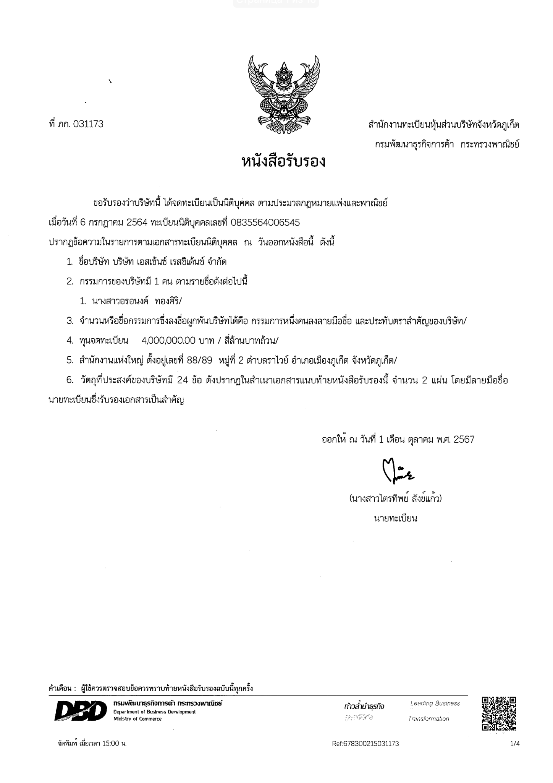

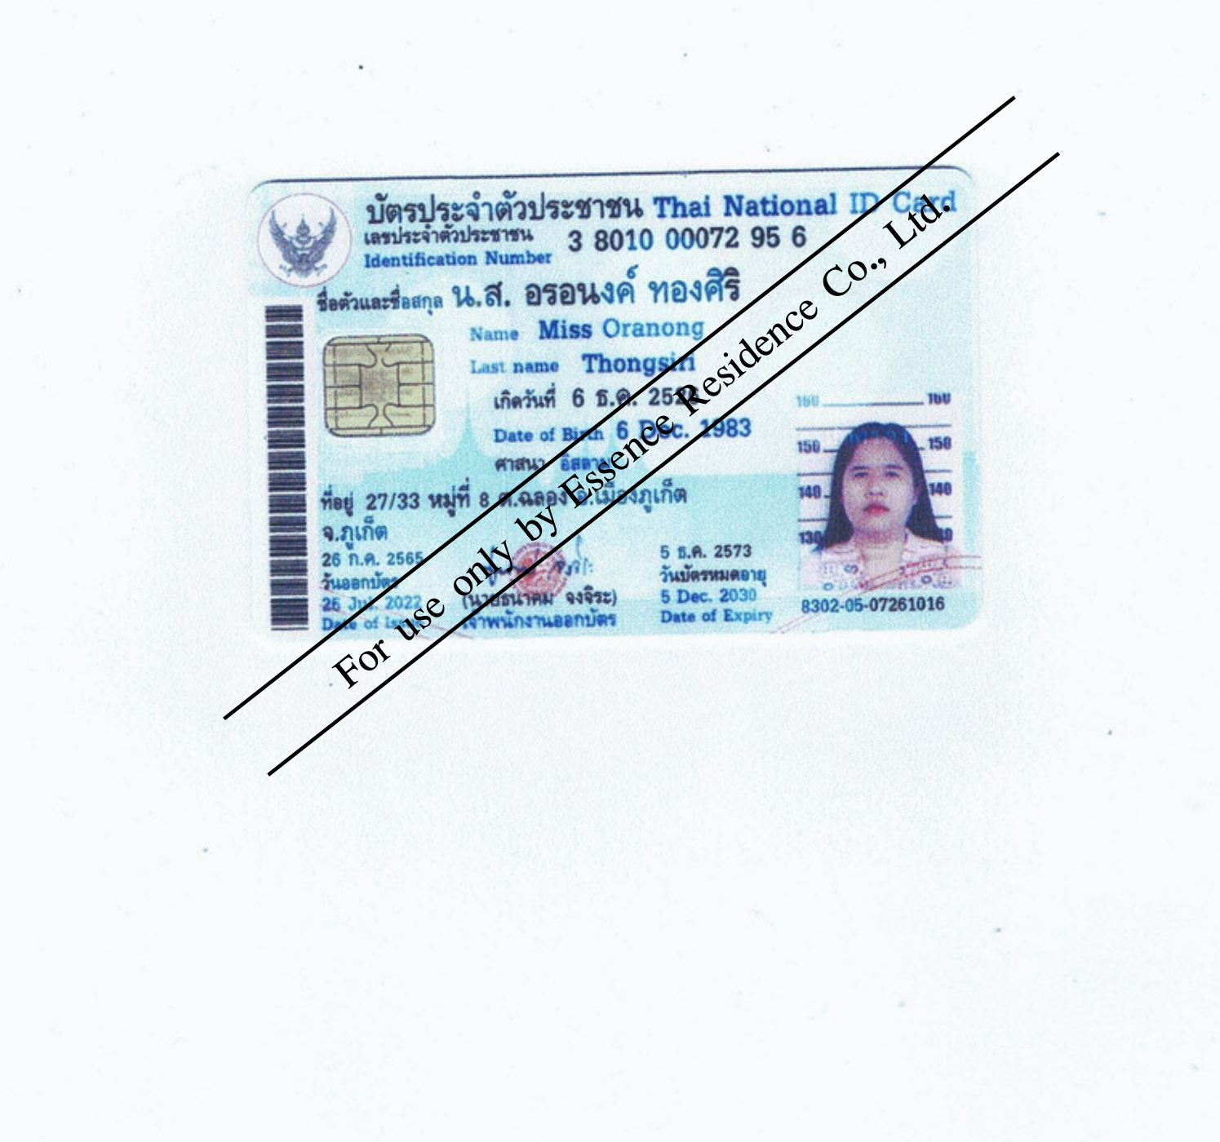

Exhibit B
Copy of Lessee’s ID card/passport

Exhibit C
Condominium Project Land

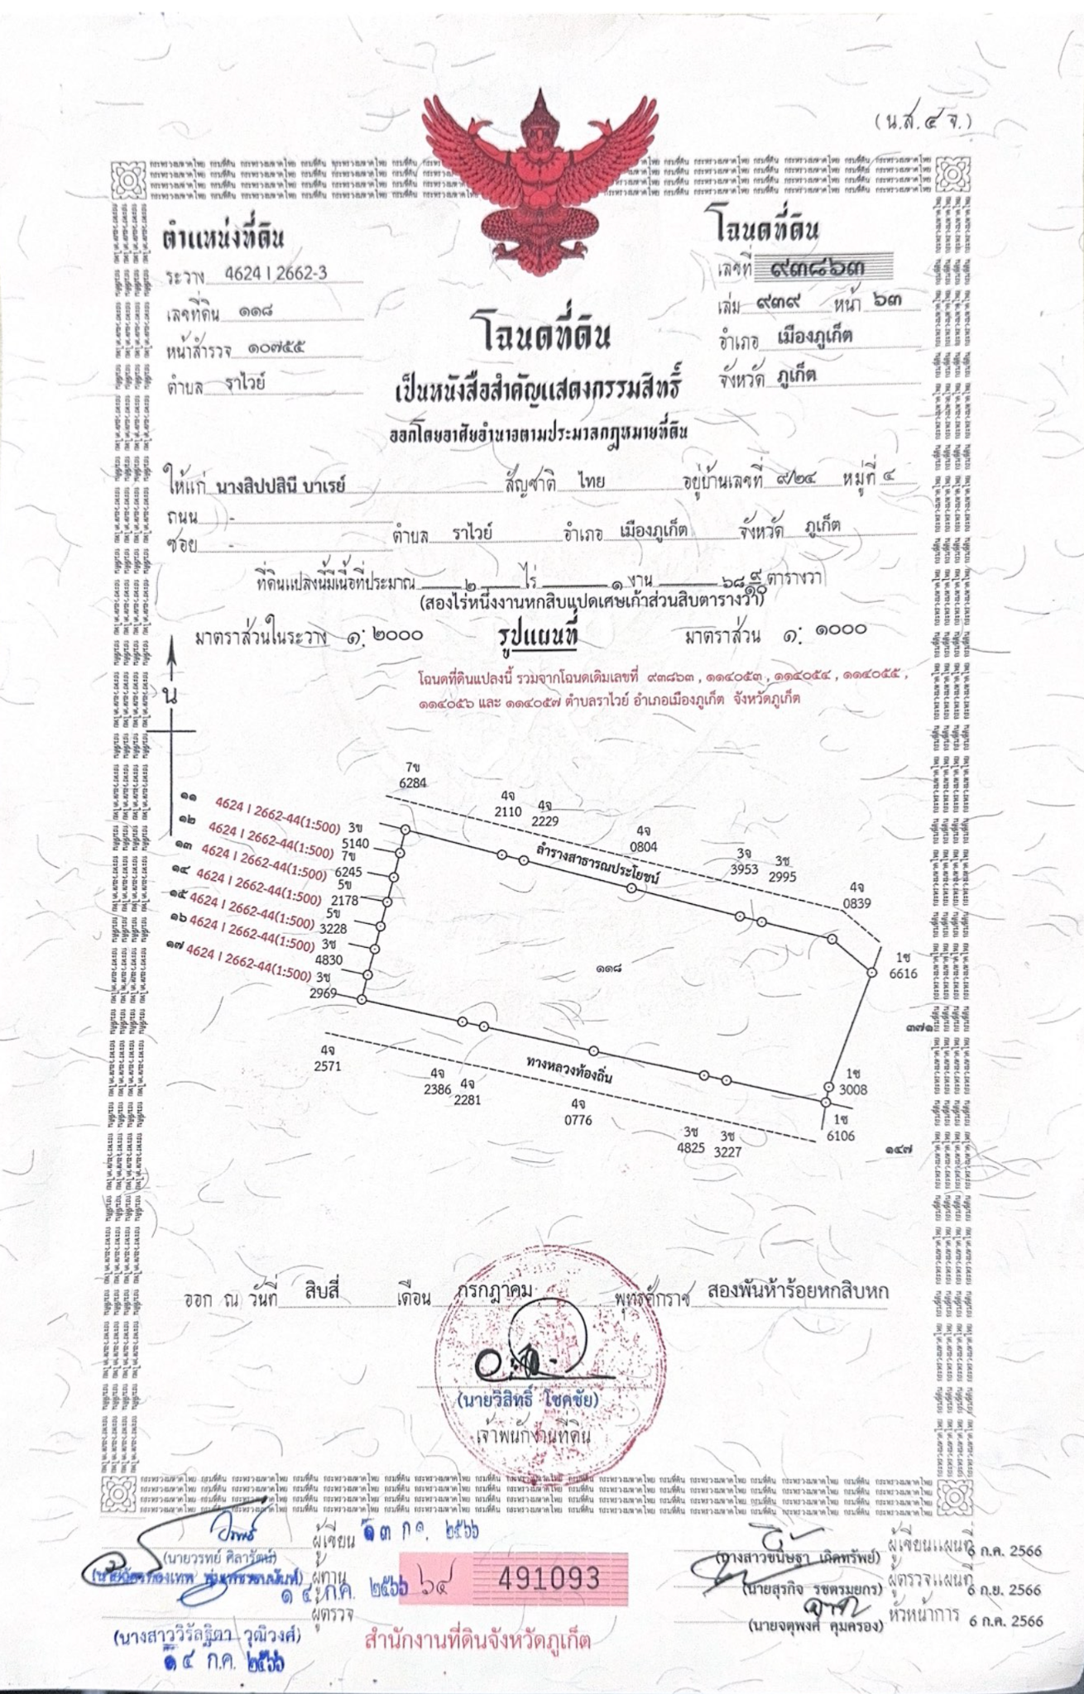

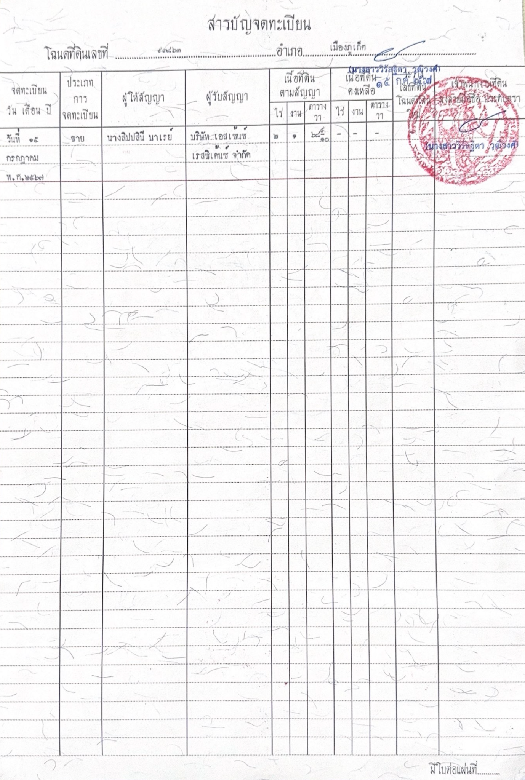
Exhibit D
Leasehold Unit plan, Floor plan, Master plan

Exhibit E
Specification

1. General:
1.1. The load-bearing frame is made of monolithic reinforced concrete (columns and slabs).
1.2. External envelope structures are constructed of expanded clay concrete panels and bricks.
1.3. The substrate for the finish flooring is a cement-sand screed.
1.4. The exterior openings are filled with window constructions using aluminum profiles.
1.5. Fencing of balconies and terraces is made of tempered glass.

2. Finishing:
2.1. Walls: in all rooms, except bathrooms - painted with water-soluble matte dispersion paint in light colors, in bathrooms - ceramic tiles.
2.2. Floor: according to the design project, ceramic tiles or parquet flooring. Bathroom - ceramic tiles in combination with the color (shade) of tiles on the walls of the bathroom.
2.3. Ceiling: in all rooms, except bathrooms - white spraying without painting or puttying and painting with matt white water-dispersion paint, moisture-resistant HDF painted with moisture-resistant paint or suspended ceiling with built-in lighting lamps.

3. Equipment and built-in furniture:
3.1. Doors: interior and bathroom doors are installed according to the design project.
3.2. Sanitary equipment: bathtub or shower cabin; toilet bowl; washbasin; washbasin mixer, shower set.
3.3. Air conditioning system
3.4. Kitchen: kitchen unit and kitchen island in accordance with the design project, dishwasher.
3.5. Living areas: TV areas, wardrobes, wardrobes, storage systems according to the design project
3.6. Lighting: in all rooms recessed luminaires or suspended lighting systems according to the design project.
3.7. Bathroom: the filling of the bathroom and the size of the sanitary equipment depends on the type of apartment according to the design project. A wall-hung toilet, sink, shower and hanging shelves, glass enclosure will be installed, washing machine.
3.8. Smart home system.

4. Furniture package:
4.1. Kitchens: Built-in appliances (hob, oven, electric hood) and electric appliances (fridge, electric kettle). The amount of cutlery and crockery depends on the type of apartment.
4.2. Living rooms: the filling of the living room and the size of the furniture depends on the type of apartment according to the design project. There is a sofa, TV 65 inches, TV cabinet, coffee table, working table with chair, armchair.
4.3. Bedrooms: the filling of the bedroom and the size of the furniture depends on the type of apartment according to the design project. The bedroom is equipped with double beds, make-up table, TV 65 inches, TV cabinet.

General remarks: All apartments will have mirrors, switchbot curtains for windows.
Disclaimer:
In the event of changes in the product line by the manufacturer and in other cases, including in the event of impossibility of installation due to the parameters of the premises, the Developer shall make appropriate changes to the finishing package specified in this Appendix without compromising the quality of materials and equipment.

Addendum to the Agreement of Condominium Leasehold Unit No … between

Essence Residence Co., Ltd., (“the Lessor”) and … (“the Lessee”): shall be called the “Agreement”

WHEREAS, the parties wish to add certain provisions of the Agreement:

NOW THEREFORE, the parties agree as follows:

The Lessor consents and confirms that The Rental of Leasehold unit in the sum of … THB (… Baht Only) to be paid by the Lessee under the Agreement executed by the parties hereto, constitutes the full rental amount for the initial 30 (thirty) year lease term, and for the first consecutive renewal lease term and second consecutive renewal lease term referenced in paragraph 2 below. The allocation of the Rental Consideration in the sum of … THB (… Baht Only) to be paid by the Lessee per the Agreement is allocated as follows:

For the Initial 30 (thirty) year lease term of … THB (… Baht Only)
For the first 30 (thirty) year renewal lease term 0 THB
For the second 30 (thirty) year renewal lease term 0 THB

      - All Parties agree that the total combined lease terms under this Agreement and the two new renewal lease terms shall not exceed ninety (90) years. Both Parties agree that the Lessee shall not pay any further rental consideration over and above the Rental Consideration which constitutes payment for the full rental amount for the initial 30 (thirty) year lease term and full pre-payment for the first consecutive renewal lease term and second consecutive renewal lease term referenced in paragraph 2 below.

The Lessee shall pay the cost of all registration fees, stamp duty, and transaction taxes, due and payable at the land office, upon registration of the first 30 (thirty) year lease renewal term and second 30 (thirty) year lease renewal term.

The Lessee shall exercise the lease extension right by giving written notice thereof to the Lessor not less than 90 (Ninety) days prior to the expiration date of the lease term under the Agreement in order to establish the time and date to make and register a new lease term.

      - Upon expiration of the lease term specified in Clause 3 of the Agreement, the Lessor agrees to allow the Lessee to Lease for two (2) full additional terms of thirty (30) years each or for the maximum period then available under applicable law at the time of each such renewal whereby the Lessor. Such lease shall be subject to the same provisions and conditions as the original Agreement.

      - If the Lessee plans to use the unit for profit, including leasing it to third parties, the Lessee agrees to sign a contract with the Lessor's Property Management Company for a term of 5 (five) years for Property management services or Guarantee Rental Agreement (hereinafter referred to as the "Management Agreement") at the moment of signing the handover and acceptance report for the premises.

      - The Management Agreement with the Property Management Company shall include terms defining the responsibilities of the Property Management Company in relation to the Lessee's condominium management, as well as terms for payment of services, with the following key conditions:

4.1. For studios and 1-bedroom units:
• Guarantee Rental Program - 6% (Six percent) of the Unit Price per year,
OR
• Property Management Program - profit from renting out the unit shall be split between the Lessee and the Property Management Company, with the Lessee receiving 70% (Seventy percent) and the Property Management Company receiving 30% (Thirty percent) if any.

4.2. For Duplex and 2-bedroom units:
• Property Management Program - profit from renting out the unit shall be split between the Lessee and the Property Management Company, with the Lessee receiving 70% (Seventy percent) and the Property Management Company receiving 30% (Thirty percent) if any.

      - Both Parties agree that this Addendum will be binding on the legal heirs, the heirs according to the will, an executor, or the property manager of the Parties as well and any disputes of this Addendum will be proceeded under the Phuket Provincial Court.

      - Unless otherwise specifically stipulate herein, the other provisions of the Agreement shall remain in full force and effect. Both Parties having read, heard and fully understood the terms and conditions herein with contained agree they are correct in accordance to their intentions and do hereunto their signature in the presence of witnesses bearing important testimony hereof. This Addendum is made in duplicate having equal tenor and effect of which each Party respectively shall keep one copy hereof.

LESSOR: LESSEE:

_______________________ _______________________
(Essence Residence Co., Ltd.)
By Ms. Oranong Thongsiri, authorized director.

Witness: Witness:

_______________________ _______________________
( ) ( )

Hotel Use Consent Letter
จดหมายยินยอมเพื่อประกอบการโรงแรม

Date: __________ 2023

วันที่
To: Essence Residence Co., Ltd. (“Company”)
ถึง: บริษัท อีวีจี พร็อพเพอร์ตี้ ดีเวลลอปเม้นท์ จำกัด (“บริษัท”)
Attn: Directors
เรียน: กรรมการ
From: Mr.
เอกสารที่
โทรศัพท์: Email address:
And
และ
In connection with the Documents and as a condition under the Condominium Unit Lease Agreement, by this letter, we hereby give the following irrevocable consent to that:
โดยหนังสือฉบับนี้ ข้าพเจ้าขอให้ความยินยอมกับบริษัทที่เกี่ยวข้องและตกลงจะไม่ใช้สิทธิเพิกถอนตลอดไป ดังต่อไปนี้
- We wholly accept that company can present this letter to any Thai Governmental authority in relation to the obtaining of a hotel license for the operation of a hotel at the Condominium and that we wholly and irrevocably accept such use on the private and common property of the Condominium.
ข้าพเจ้าขอให้ความยินยอมทั้งปวงแก่บริษัทให้สามารถให้หนังสือนี้กับหน่วยงานของรัฐที่เกี่ยวข้อง เพื่อการขอใบอนุญาตประกอบการโรงแรม เพื่อทำธุรกิจโรงแรม ข้าพเจ้าให้ความยินยอมทั้งปวงในการนำห้องชุดของข้าพเจ้าออกมาเพื่อประกอบการโรงแรม โดยจะไม่ใช้สิทธิเพิกถอนตลอดไป
- We will sign all necessary agreements; documents; forms and other instruments incidental to and/or necessary to give effect to this consent and to facilitate you obtaining the hotel license.
ข้าพเจ้าตกลงที่จะลงนามในบรรดาข้อตกลง เอกสาร แบบฟอร์ม หรือเอกสารใดๆ ที่เกี่ยวข้องหรือจำเป็นสำหรับการให้ความยินยอมนี้ เพื่อให้ความร่วมมือกับ ท่านในการขอใบอนุญาตประกอบการโรงแรม

Should we fail to abide by the terms of letter, we accept we shall be deemed in breach of the Condominium Unit Lease Agreement
หากข้าพเจ้าไม่ปฏิบัติตามข้อตกลงในหนังสือฉบับนี้ ให้ถือว่าข้าพเจ้าผิดสัญญาเช่าห้องชุด

Please be informed accordingly.
จึงเรียนมาเพื่อทราบ

Yours sincerely,
ขอแสดงความนับถือ

