BAMBOO FOREST
SALE AND PURCHASE AGREEMENT
(FREEHOLD)

CONDOMINIUM UNIT SALE AND PURCHASE AGREEMENT (FREEHOLD)
THIS AGREEMENT is made on this … at 88/2 Moo2 Rawai Sub-district, Mueang Phuket District, Phuket
BETWEEN:
Maestro Luxury Apartment Co., Ltd., a company duly registered in Thailand with Company Registration Numbered 0835565004589 whose registered office is at 177/30 Moo 4, Srisoontorn Sub-district, Talang District, Phuket Province Thailand, represented by Ms. Oranong Thongsiri as the authorized director [A copy of the Certification Document is attached in Appendix 1,2 to this Agreement.] (the “Seller”) and

… (the “Purchaser”). [A copy of the Certification Document is attached in Appendix 3 to this Agreement.] (each party individually referred to as a “Party” and collectively as the “Parties”)

WHEREAS:

- The Seller is the developer of BAMBOO FOREST (hereinafter referred to as the “Condominium Project”) located and will be constructed on the land designated by Land Title Deed No. 73741 Cherngtalay Sub-District, Thalang District, Phuket Province, aggregated area of approximately 3 Rai – 3 Ngan 87.5 Square Wah or approximately 6,350 Square Meters, (hereinafter referred to as the “Condominium Project Land”), attached hereto and marked Exhibit 4.

- The Seller agrees that when the construction of Condominium project is completed, The Seller shall register it as the condominium in accordance with Thai law.

- The Seller agrees to construct the 1 (One) Condominium project comprising upwards to 135 (One Hundred Thirty Five) condominium units located within 3 (Three) buildings, hereinafter referred to as the “Condominium”.

IT IS HEREBY AGREED as follows:

- DEFINITION

  - The Sale and Purchase Agreement: means this Agreement and the Appendix attached hereto, and includes any subsequent amendments made in accordance with its terms in the manner provided herein.

  - Unit: means Condominium unit number .., located at … floor, building …, with an approximately area including with balcony of … square meters.

  - Condominium project: means Bamboo Forest Condominium project located in Cherngtalay, Talang, Phuket, comprising 135 (One Hundred Thirty Five) Units.

  - Condominium Act: means a building in that persons are able to divide ownership in the building in parts where each part comprises ownership in personal property and co-ownership in common property.

  - Co-owners: means the owners of the Condominium Units in the Condominium.

  - Condominium Project Land: means Land Title Deed No. 73741 Cherngtalay Sub-District, Thalang District, Phuket Province, aggregated area of approximately 3 Rai – 3 Ngan 87.5 Square Wah or approximately 6,350 Square Meters.

  - Private Property: means a Condominium Freehold Unit and any construction registered on the property of the individual owner of that Condominium Freehold Unit.

  - Common Property: means the completed driveways walkways, electrical systems, plumbing systems, gardens, swimming pool, office facilities, etc, and amenities provided by the Seller, which is not individually owned by any Purchaser.

  - Regulations: means the Regulations apply to Co-owners of Condominium Project.

  - Registration Date: means the date on which the Parties registered the Purchase at the Phuket land office.

  - Completion Date: means the date on which the construction of the Freehold Unit will be completed shall not be later than 31th of December 2027.

  - Condominium Juristic Person (CJP): means the Juristic Person supervises, manages, resolves any issues and, is responsible for any works assigned by the CJP Committee, Co-owners, etc for the good order of the Condominium.

  - Sinking fund: means is the one-time payment payable by the Co-Owners to the Condominium Juristic Person as a reserve fund for repair or replacement of the Common Property and other management prescribed in the Regulations.

  - Common Area fee: means the amount of monies that each Co-Owner is responsible to pay to the Condominium Juristic Person as prescribed in the Regulations.

  - PP/SQM: means the number of differences of the excessed or deducted areas per square meters.

  - Establishment Date: means the date the CJP is completely registered with the Competent Authority.

  - Condominium Registration Date: means the date of registration of the Condominium.

- AGREEMENT TO SELL AND PURCHASE

  - “Condominium Building”, “Common Property”, “Private property”, “Co-ownership”, and “Juristic Condominium” shall have the same definitions as those given in the Condominium Act B.E. 2522 as amended.

  - The Purchaser agrees to purchase and the Seller agrees to sell condominium unit number(s) … located of condominium building on … floor, unit type …, with the area of … square meter, whose fully detailed particulars appear in the Unit plan, Floor plan, Master Plan, and specification attached hereto and marked Appendix 5 (hereinafter referred to as the “Unit”) for the Purchase Price referred to in Clause 3.

  - On the date of the transfer of the ownership of the Unit, the Purchaser shall have private ownership in the Unit and co-ownership with the other co-owners in the Common Property.
- PURCHASE PRICE

  - The total purchase price of the unit is … (…baht only) (the “price”)

  - Foreign freehold quota fee shall be calculated at 10,000 THB (Ten Thousand Baht Only) per square meter.

  - Total price for the unit is … (… baht only) which the purchaser shall be paid as per the following payment schedule.

  - The Price mentioned above includes the built-in furniture and the furniture package provided in Appendix 6.

- PAYMENT SCHEDULE

1st Installment: The deposit of … (…Baht Only) has been paid to the Seller on …

2nd Installment: The sum of … (… Baht Only) shall be paid to the Seller within …

The amount of Sinking fund and Common Area fee should be paid on handover date.
  - Payment transfer details. All payments of the Purchase Price under the Payment Schedule shall be made to the Seller by telegraphic transfer to:

Account Name: Maestro Luxury Apartment Co., Ltd
Bank: KASIKORN BANK PCL
Branch: HAYAKCHALONG PHUKET
Account Number: 126-3-67721-4
Swift Code: KASITHBK
Message: For the purchase of Freehold unit …, Bamboo Forest, on behalf of ….

  - The Purchaser shall transfer the Purchase price of the unit from off-shore into Thai bank account of the Seller or the Purchaser’s representative in any foreign currency without applying the conversion into Thai currency as stated in accordance with the Condominium Act. However, the money that the Purchaser transfers into the account in Thailand after deducting the relevant fee must be not less than or equal to the Purchase Price of the Unit.

All bank charges in connection with the conversion of foreign currency into Thai Baht, as a result of inward remittance or transfer of funds, shall be borne solely by the Purchaser.

It is the Purchaser’s responsibility to use the correct payment details description, as shown above, upon transferring the money from abroad in order to obtain the Foreign Exchange Transaction Form (FET) or the bank certificate stating the correct reason for payment. Once the Seller receives the Purchase price, the Seller shall be responsible to prepare the bank certificate or other relevant documents for the Unit registration.

  - All cost and bank charges incurred to remit all payments under the Booking contract and this Agreement shall be paid by the payer. The amount credited to the recipient’s bank charges and/or exchange rate fluctuations shall be adjusted in the subsequent payment where applicable and subject to any such payment being within not more than two percent (2%) of the total amount due under each installment whereupon all such differences shall be settled collectively on payment of the final installment or payment as the case may be according to the Agreement.

  - In the event of any dispute between the parties regarding payments hereunder the copy of the original the remitting bank’s remittance order or/ and copy of e-receipt shall be accepted as proof of payment and the date the payment is discharged shall be the date the payment is credited to the recipient bank account of the thereof.

- COMPLETION DATE

  - The Seller agrees that the construction of the Condominium unit shall be completed within 31th of December 2027. (the “Completion date”).

In the case where it is necessary for the construction to be delayed or suspended by any event of the Force Majeure or events beyond the control of the Seller, the Completion Date is to be extended no longer than one (1) year (the “Extension of Completion Date”). In such event, the Purchaser agrees that the Seller shall be entitled to extend the Completion Date by serving a written notice of such event on the Purchaser within 30 (Thirty) days.

  - The Seller represents and affirms that the Condominium Unit and the Common Property shall be completely constructed in a good and workmanlike manner with materials and specifications in accordance with the Applicable Law or as set out herein.

  - In the case where the Registrable Area is less than the Saleable Area, the error may give The Purchaser an entitlement to an adjustment of the purchase price for the difference in excess of 5 (five) percent of the Saleable Area (if any) calculated proportionally with the PP/SQM on such excess. The Purchaser is entitled to deduct the Final Payment with the result from the adjustment; the balance in this case shall be the Final Payment under this Agreement. In the contrary, the Seller shall have the same entitlement where the Registrable Area is more than the Saleable Area for the difference in excess of 5 (five) percent of the Saleable Are, in this case, the said calculation shall apply, mutatis mutandis and any increment of the purchase price shall be added with the Final Payment and shall be deemed the Final Payment hereunder.

- INSPECTION AND ACCEPTANCE OF THE UNIT

  - Upon the completion of Unit, the Seller shall inform the Purchaser to conduct a physical inspection of the Unit. The Purchaser or its duly appointed representative must appear and conduct the inspection of the Unit on the date specified by the Seller (“Inspection date”).

  - If the Purchaser fails to show up on the Inspection date for any reason, it shall be deemed that the Purchaser agrees to accept the unit immediately and the Purchaser is still obligated to pay the Purchase price to the Seller without resisting.

  - In case the unit has defects or it is not complete according to the terms, conditions, and specifications of this Agreement, the Purchaser shall notify the Seller in writing with all details and send written notice specifying the description to the Seller and The Seller shall commence work to effect complete remedy, repair or new replacement immediately within 30 (thirty) days of receiving notice thereof from the Purchaser.

The Parties acknowledge and agree that the defects of the units will not affect the Unit registration and the Purchaser will not claim any costs of such defects.

- DEFECT LIABILITY

The Seller shall resume defect liability which may incur due to defect of the Unit in the following cases:

  - In the event of defects in the structural part of the Unit, the liability period shall be 5 (Five) years from the moment of commissioning of the facility.

  - In the event of defects in the non-structural part of the Unit, the liability period shall be 2 (Two) years from the moment of commissioning of the facility.

The Seller shall remedy the defect incurred to the condominium within 30 days from the date that the Purchaser or condominium juristic person, as the case may be, has notified in writing for such defect except in case where such defect needs urgent remedy which the Seller has to commence immediately after being notified. If the Seller fails to remedy such above-said defect, the Purchaser or condominium juristic person, as the case may be, is entitled to make its own remedy or hire other person to do so for which the Seller agrees to reimburse the damages or expenses for such defect remedy.

- MATERIALS AND EQUIPMENT USED IN THE UNIT AND COMMON PROPERTY

The initial particulars of the materials and equipment to be used in the Unit are shown in Appendix 6 attached herewith. For the benefit of the project and compliance with the regulations, instructions, notifications, permits and/or approvals of authority, the Seller reserves the right to change any specifications and use other materials or equipment as necessary, provided that, the alternative materials or equipment must be of comparable to or better quality than the materials and equipment specified in Appendix 6, as the case may be. In addition, the Seller reserves the right to amend the specifications and/or construction plan if required by relevant law or building regulations.

- ESTABLISHMENT OF THE CONDOMINIUM JURISTRIC PERSON (CJP)

The Seller at their own cost and expense shall register the CJP with the Competent Authority and shall obtain its certificate within 30 (Thirty) days following the Condominium Registration Date. The Seller shall be also responsible to prepare and register the Regulations with the Competent Authority at the time of such establishment of the CJP. (“Establishment Date”).

It is clearly understood that the Condominium Registration Date and CJP Registration Dates can be set ONLY upon receiving relevant documents/information from competent Authorities therefore the Seller is to be released from any liability in case of registration delays which are attributable to the Governmental Authorities.

- REGISTRATION

  - When the construction of the unit and all common areas of the condominium is completed and the Seller has obtained the Condominium license or relevant permits accordingly and the Purchaser has paid all Purchase payments to the Seller, the Unit registration shall proceed at the Land Department within 12 (Twelve) months from the Establishment Date (the “Registration Date”).

The Seller shall notify the Purchaser by giving 30 (Thirty) days in advance notice in order to register with the competent Land office and /or any other competent authority.

If the Purchaser is unable to register the lease right on the Registration Date by actual presence, the Purchaser shall appoint an attorney or the Purchaser’s representative to carry out the registration with the Seller or its representative on the Unit Registration Date.

  - The Seller and the Purchaser are equally responsible basis on a of 50-50% for all registration fees, all taxes, duty stamp fees, and other expenses incurred to the Unit Registration.

  - If the Purchaser or Purchaser’s duly authorized representative fails to accept the transfer of ownership to the Unit on the Registration Date, without the Seller’s default and which cannot be remedied by the Purchaser within thirty (30) days after notice from the Seller, then the Purchaser acknowledges and agrees that he should pay to the Seller a penalty of 100,000 THB before next registration date would be arranged.

  - Where the Purchaser is a non-Thai natural person or a non-Thai juristic person, the Seller must obtain from a commercial bank in Thailand evidence of its remittance of foreign currency from offshore or other evidence as required by the regulations of the Land Department of Thailand and the Thai Condominium Act.

- ASSIGNMENT

  - The Purchaser agrees not to assign or transfer any rights or obligations under this Agreement to anyone (“Assignee”) until the Registration Date or until the Seller has sold and/or leased eighty per cent (80%) of all units in the Project or the Completion Date, whichever is earlier; except with the prior written consent of the Seller.

Purchaser is entitled to assign his/her right and obligation according to this agreement to the third party under the terms and conditions as follows:

  - The Purchaser has no unpaid outstanding installment, common area fee or other expenses according to this agreement.

  - In case there is any payment arising from this assignment, the Purchaser shall be responsible for such amount.

  - The new Purchaser has to take all right and obligation according to this agreement and all attachment and the parties has to execute the assignment agreement which provided by the Seller.

  - Such assignment shall not render the ratio of foreign ownership in the condominium to be excess of those specified by law.

  - Such Assignment, the Purchaser shall pay the assignment fee in the amount of 100,000 THB in order to arrange the assignment agreement, new sale agreement and other relevant documents (if any) to the Seller as representative for this assignment on the date of all parties agree to amend in written notice.

However, the Seller reserve the right to reject such assignment if the Seller evaluate that such assignment shall accrue the breach of the agreement.

- UTILITIES

  - The Seller will be responsible for installing water and electricity meters for the unit.

  - The Seller shall provide installations of electric and water meters to measure the amount of electric consumption and the volume of water total usage within the Condominium. The Seller shall set up an integrated metering system or other systems the Seller may later seem more appropriate for the Condominium Project in accordance with the Applicable Law, the Seller shall directly connect the main meters with the public services provider or the Competent Authority.

  - The Seller shall provide separate electric and water sub-meters for each and all condominium units in the Condominium for calculating the overall and separate amount and volume of electricity and water consumed between the Common Property and by the Co-Owner.

  - It is understood that if the Seller has reserved money for the installation of electric and water meters, The Purchaser is required to reimburse the Seller for these expenses on the Registration date or the date as specified by the Seller.
If there is anything to change about the water and electricity meter, the Purchaser shall prepare the documents for the change and pay the administrative fee at their own expense.

- COVENANTS

The Purchaser hereby agrees as follows:

- To use the Unit for residential purposes only, and not to use the Unit as a place for engaging in business activities or selling goods or providing services or engaging in any other activities that are immoral or likely to cause nuisance or annoyance or inconvenience to other unit owners and not to cause any excessive noise or obnoxious smells;

- Subject to the foregoing, the Purchaser can keep any pets in the Unit, in any numbers, if a preliminary the prior written consent granted by the Seller or the Juristic Condominium.

- Not to do anything to the Common Property and private property others that will cause annoyance, nuisance or damage to the other unit owners and not to leave any of the Purchaser’s property or refuse in the passageways or any other part of the Condominium Building that is shared with other Unit owners;

- Not to remove, add to or alter the Unit or any part thereof that may affect the structure, the engineering stability or the architectural style or appearance of the Condominium, without prior written consent from the Seller which may be granted unconditionally or subject to conditions imposed by the Seller and or/its appointed engineer or other expert, whose fees shall be paid by the Purchaser;

- As from the date of the Registration, to be responsible for the Purchaser’s share of the expenses arising from the maintenance of the Common Property as stipulated in Clause 14 (b), including but not limited to, the hiring of security guards, cleaners, maintenance staff, common utilities bills, and costs of repair and customary and usual maintenance. Such expenses shall be paid in accordance with the rules and regulations of the Condominium Juristic Person; and

- To strictly comply with and adhere to the rules and regulations of the Condominium Juristic Person including the articles of association of the Condominium.

- USE OF COMMON PROPERTY

  - Throughout the term and subject to the payment of the common property fee to be charged by the Seller or its representative, the Purchaser shall be entitled to use the Common Property and facilities of the project provided by the Seller.

  - The Purchaser agrees to strictly abide and comply with the regulation from time to time in force in respect of the use of the common property of the project and all regulations imposed in relation thereto. The Purchaser further agrees to be responsible for the proportion of all costs and expenses incurred in the management of the common property of the project and upkeep of the common property and other facilities including, inter alias, any parking lots, plant, machinery, and equipment and other thing provided for the common benefit of all Purchaser in proportion, accordingly to the number of ratio.

- COMMON AREA FEE AND SINKING FUND

  - Common area FEE
The Purchaser acknowledges that the Common Area Fee are expenses related to the management of the Common property of the condominium project to be clean and in good condition, including cleaning, maintenance, management, and servicing of the Common Property provided for the benefit of persons residing within the Condominium Project, security guards and services, trash and garbage collection and removal, fire and other insurance premiums for the Common Property.

The Purchaser consents and agrees to pay annually in advance to the Seller a proportionate part of the total costs and the common area fee will be collected from the Purchaser at the rate of 100 Baht (One Hundred Baht Only) per square meter and will be paid on the Registration date or the date that specified by the Seller. After that, the Common Area fee shall then be determined by the resolutions passed by the Co-owner together with the owners of other condominium units as prescribed according to the Regulations of the Condominium Juristic Person.

  - Sinking Fund
The Purchaser agrees to pay to the Seller a contribution to the Sinking Fund to cover any new purchase or acquisition of necessary but non-budgeted items or capital outlay reasonably deemed necessary by the Manager of Juristic Person, as well as emergency repairs and/or replacement of essential parts and facilities of the Common Property for the benefit of the Purchaser together with other persons residing in the Project as reasonably determined from time to time by the Condominium Juristic Person. The first contribution to the Sinking Fund shall be paid prior to the Purchaser taking possession of the Condominium Unit and shall be set at 700 Baht (Seven Hundred Baht Only) per square meters.

In case the Purchaser fails to do so, the Purchaser shall be charged the interest rate of 7.5% annually counting from the date due date until the payment has been made in full.

Any subsequent contributions to the Sinking Fund and the amount of such contributions shall be determined by resolutions passed by the Purchaser together with the owners of other condominium units as prescribed according to the Regulations of the Condominium Juristic Person.

This cost of the Common Area fee and Sinking fund can be adjusted as appropriate if approved by the Co-owners of the Condominium project.

- INSURANCE

The Purchaser is solely responsible for the insurance cost to cover all risks of the unit throughout the term and renewal term to ensure that if any damage or destruction occurs in the Freehold unit, whether in whole or in part, the Purchaser will be responsible for such damage or destruction. Unless the damage or destruction is caused by the Seller’s fault or the defect stipulated in Clause 7.

It is understood that the Purchaser is obligated to restore or repair the unit to its original and good condition.

- PENALTY, DEFAULT INTEREST AND TERMINATION

  - This Agreement may be terminated by the Parties' mutual consent.

  - In the event that the Seller breaches the Agreement and does not rectify such action within a period of 30 (Thirty) days from the date of receipt of the notice letter from the Purchaser The Purchaser has the right to terminate this Agreement.

  - If the Seller fails to deliver the Unit or Complete the unit on the Completion Date, the Purchaser is entitled to the following right:

    - Claim for a daily penalty in delayed of Completion Date at the rate of 0.01% of the Purchase price or money paid calculated from the Completion Date or extension of Completion Date until the actual Completion Date (but the total penalty shall not exceed 10% of the Purchase price) OR

    - Terminate this Agreement and claim for all paid amounts under this Agreement together with an interest rate of 7.5% per annum, counting from the termination date until the date has been made in full.

  - In the event that the Purchaser breaches the Agreement, non-performance or non-observance of any matters of the essence in respect to the terms and conditions under this Agreement, including delay or failure to make the Purchase payment, and does not rectify such action within a period of 30 (Thirty) days from the date of receipt of the notice letter from the Seller, The Seller shall be entitled to terminate this Agreement and/or to forfeit the Purchase Premium and all monies paid by the Purchaser in their entirety without prejudice to the Seller’s rights to claim other costs, damages, and expenses against the Purchaser.

The Seller shall also have the right to claim for unpaid sums notwithstanding termination of the Agreement and all interest on unpaid sums at a rate of 7.5% per year counting from the due date until the payment has been made in full.

- SUCCESSION

This Agreement shall be binding upon and inure to the statutory heirs and/or the legatees of the Parties (If any) and/or application laws in Thailand.

- NOTICE

Unless otherwise stated herein, any notice, request or demand required to be served by either party hereto the other under this agreement including notice for call the General Meeting shall be sent by registered mail or email and copy the email (CC) to the contract addresses of the party as follows

To the Seller:
Postal Address: Maestro Luxury Apartment Co., Ltd 177/30 Moo 4, Srisoontorn Sub-district, Talang District, Phuket Province Thailand
Tel.:+66971150350
Email Address: sales@harmonyphuket.com

To the Purchaser:
Postal Address:
Tel.:
Email:

Any change of address shall be notified to the other party within seven (7) days from the date of such change.
Any notice, request or demand sent by registered mail it shall be deem to have been duly received upon the expiry of a period of ten (10) days posting of such registered letter. Any notice, request or demand sent by email it shall be deemed to have been duly received upon the date such email and all attachments (if any) was completely sent.

- FORCE MAJEURE

In any case where the performance of any obligation hereunder of either of the parties is prevented, restricted or interfered with by reason of:

Fire, explosion, casualty or accident, epidemic, flood, lack of or failure of sources of supply of labour, power or supplied; or War, revolution, civil commotion, acts of public enemies, blockage or embargo, epidemics, government restrictions, government lockdown or any event beyond the direct control of the Seller.

The party so affected, upon providing prompt notice to the other party, shall be excused from such performance to extent of such prevention, restriction or interference.

The preceding sentence does not excuse the Purchaser from payment of the Agreement Price or other amounts that the Purchaser is required to pay, in the amounts and at the times specified in this Agreement.

- APPLICABLE LAW

This Agreement shall be governed and construed in accordance with the law of Thailand. Should a dispute arise between the parties the English meaning shall prevail.

In the event it becomes necessary to proceed with litigation arising from or concerning this Agreement, such proceedings shall be brought to the Phuket Provincial Court for hearing, adjudication, and enforcement.

- HEADINGS

The Headings appearing in this Agreement are inserted only for convenience and in no way do they define, limit or describe the scope or the intent of the Sections or Clauses of the Agreement and have no effect on this Agreement. Any references to the singular or plural number shall be deemed to include the plural or singular number respectively and words using the masculine gender only shall include the feminine or neuter gender and vice versa as the case may be.

- ENTIRE AGREEMENT

By signing this agreement, the Purchaser agrees to receive any newsletter from the Seller.

This agreement and the schedule attached hereto constitute the entire agreement between the parties and no additions hereto nor shall modifications hereof be valid unless the same are made in writing, signed by both parties, and attached to this Agreement.

This Agreement is made in triplicate originals, one set shall be kept for each party, and another copy shall be kept at the concerned Land Department Office.

IN WITNESS WHEREOF, the Seller and the Purchaser have hereunto affixed their signatures and seals (if any) in the presence of witnesses on the date aforementioned above.

THE SELLER: THE PURCHASER:

_______________________ _______________________
(Maestro Luxury Apartment Co., Ltd.)
By Ms. Oranong Thongsiri, authorized director.

Witness: Witness:

_______________________ _______________________
( ) ( )

APPENDIX 1: AFFIDAVIT OF THE SELLER

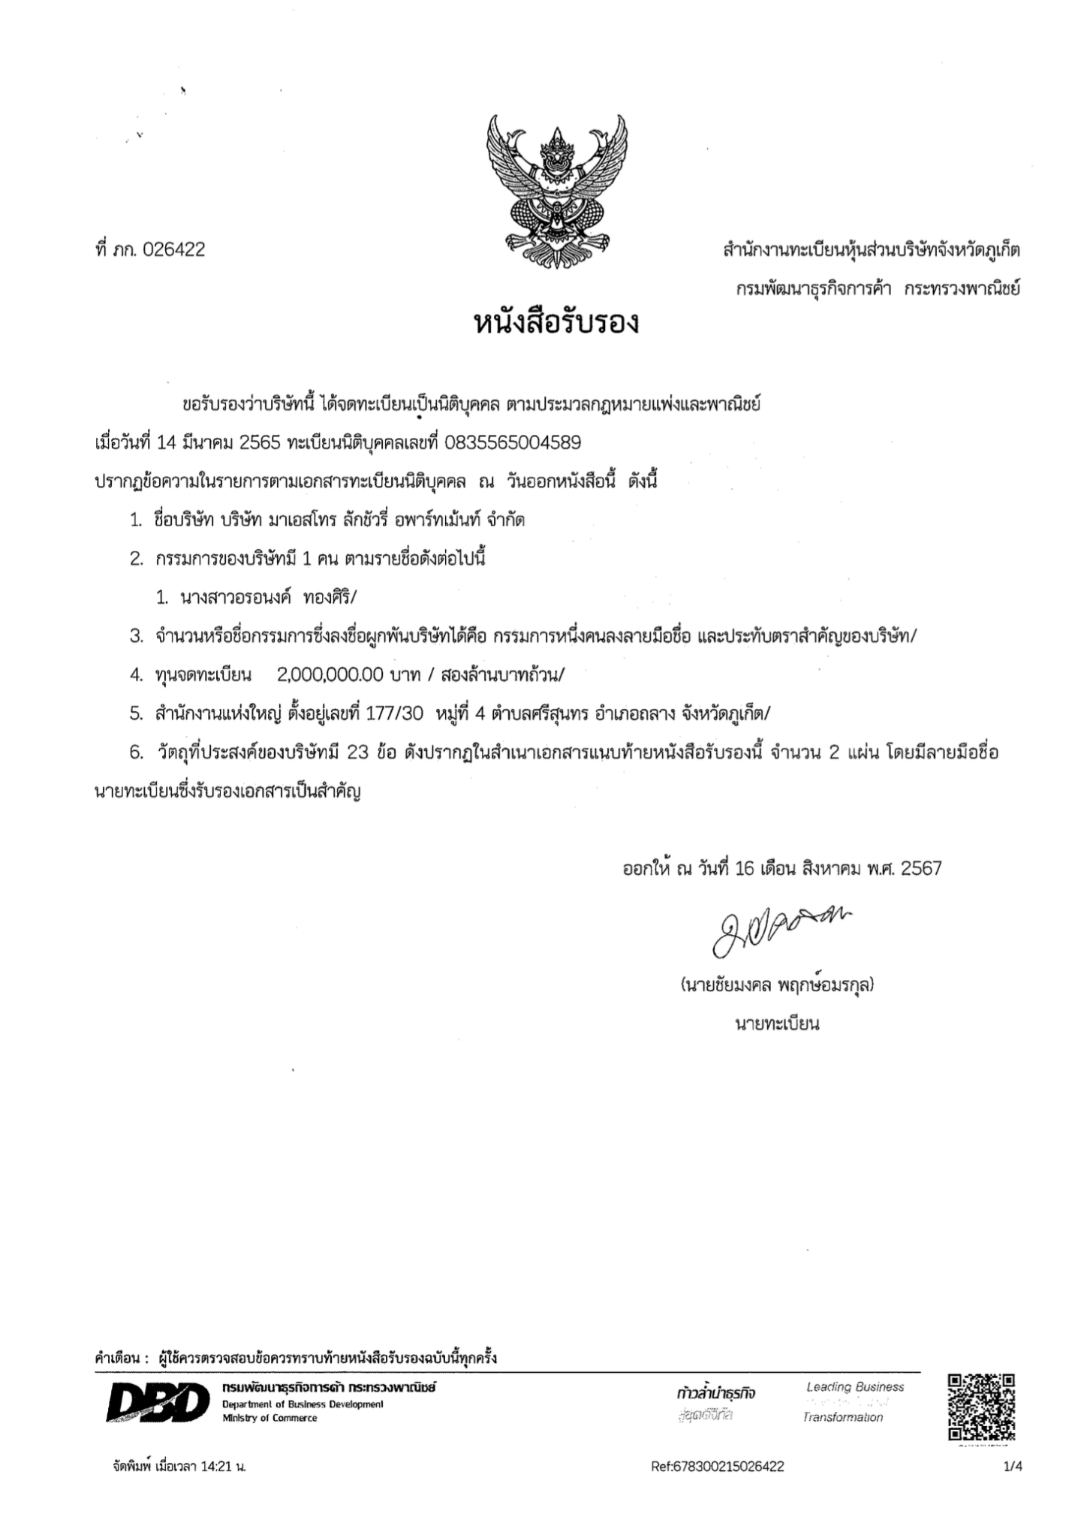

APPENDIX 2: AFFIDAVIT OF THE SELLER and DIRECTOR’S PASSPORT

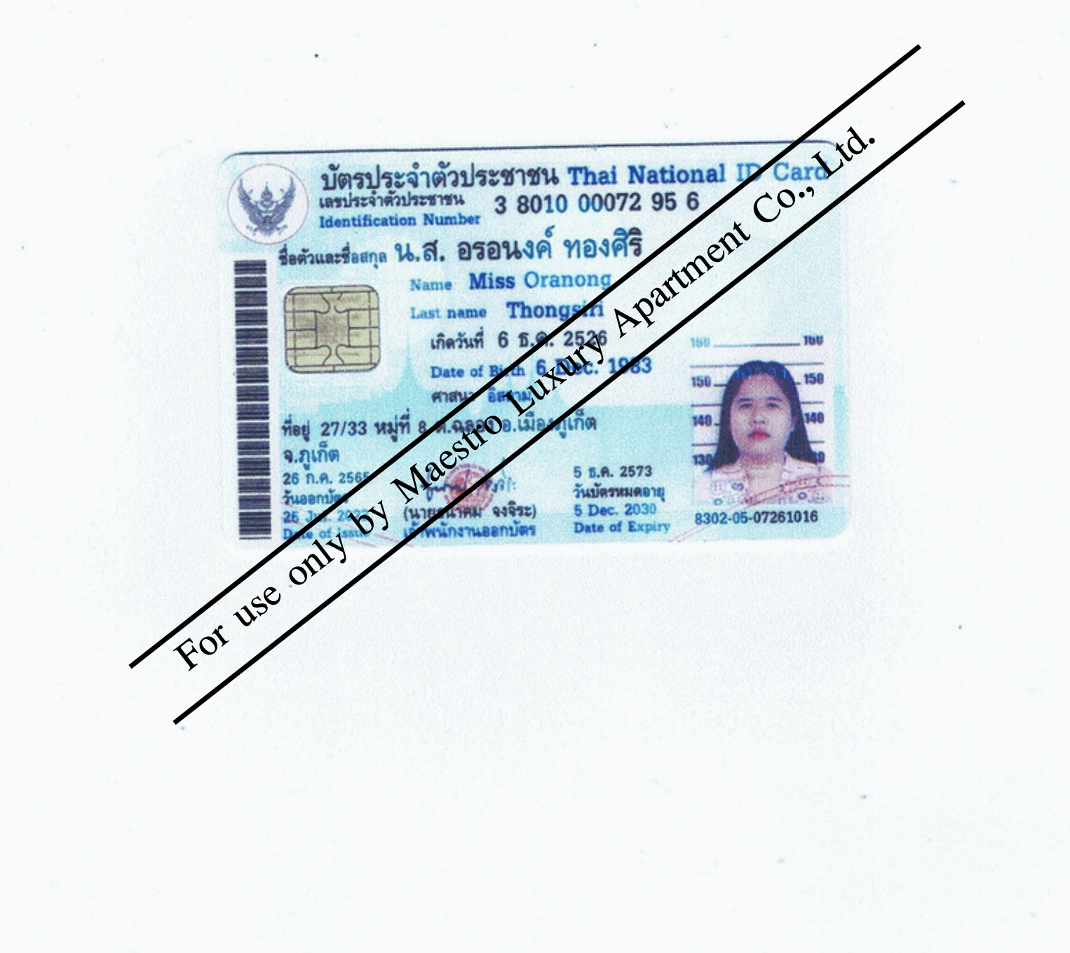
APPENDIX 3: Copy of Purchaser’s Passport

APPENDIX 4: CONDO TITLE DEED

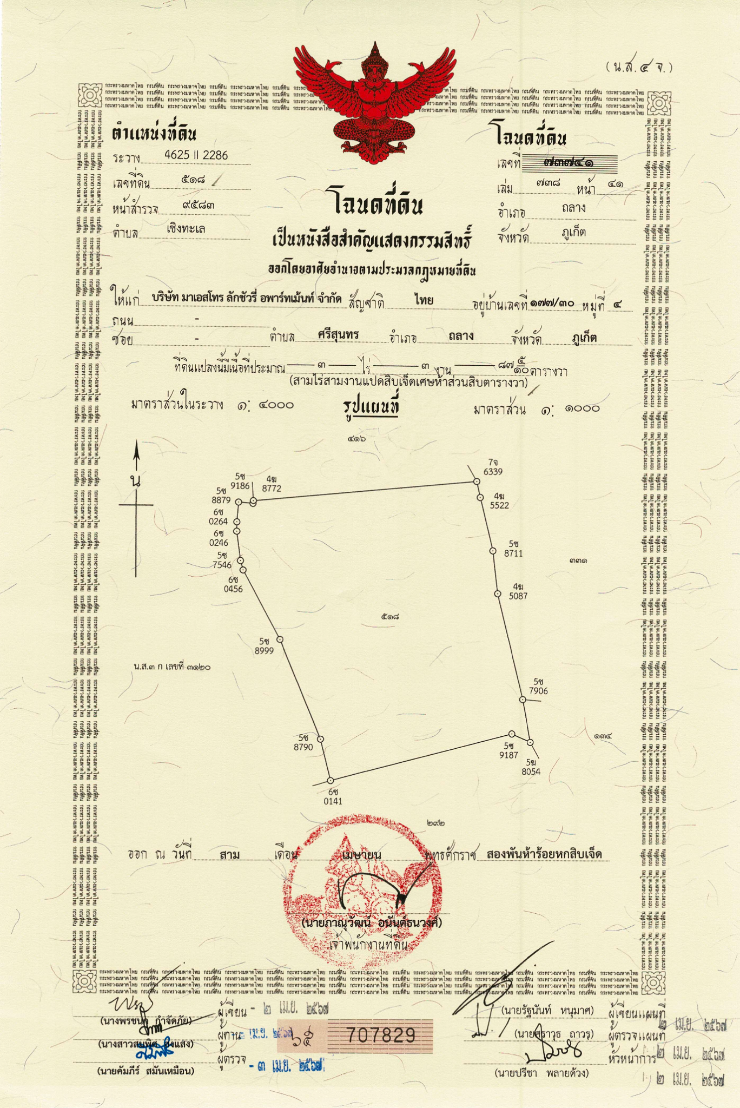

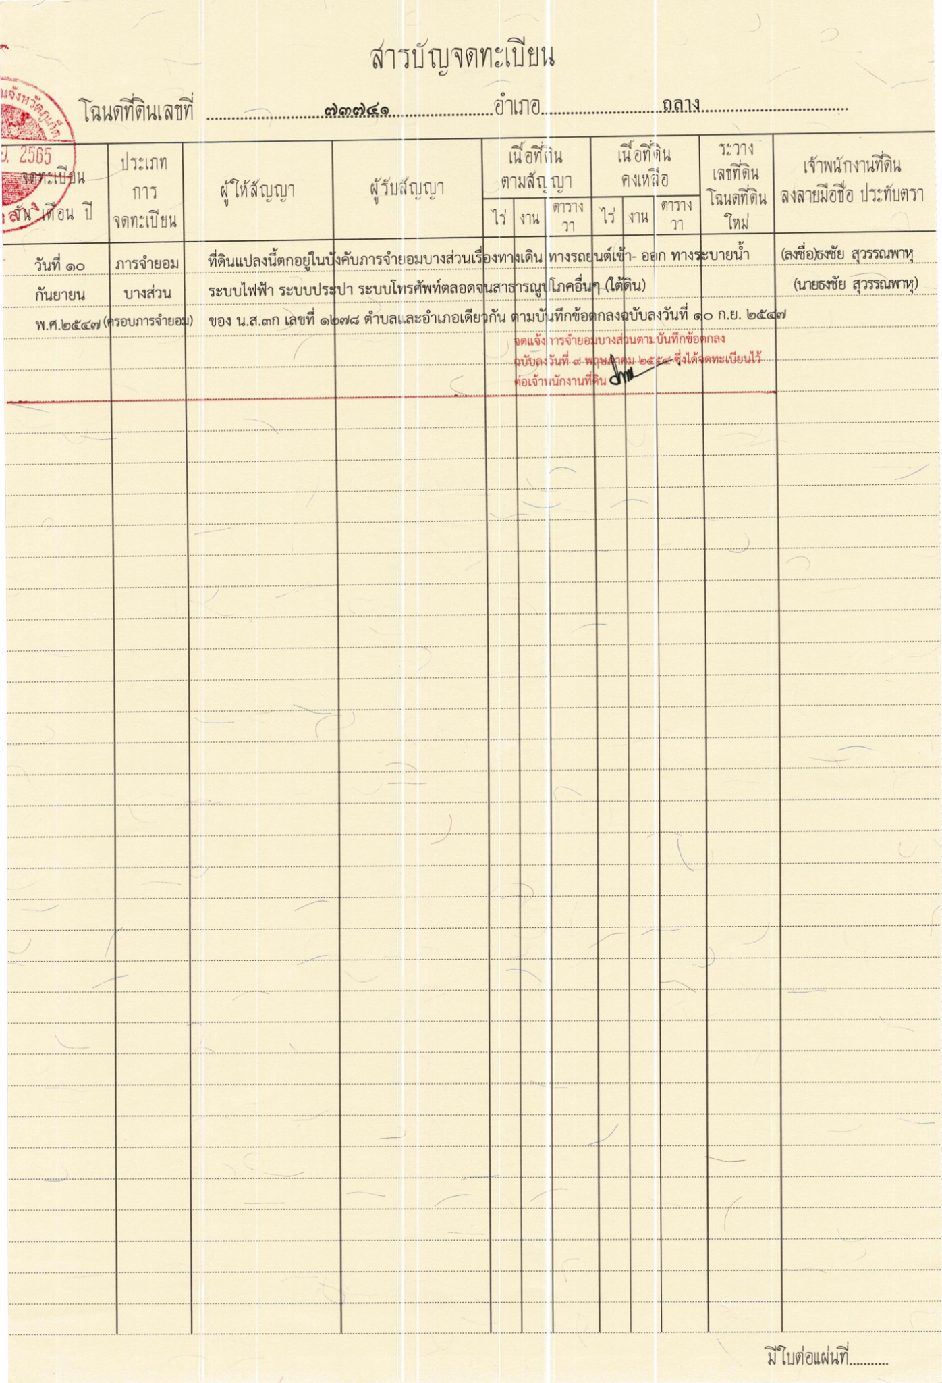

APPENDIX 5: UNIT PLAN, FLOOR PLAN, MASTER PLAN

APPENDIX 6: SPECIFICATIONS OF THE UNIT

1. General:

1.1. The load-bearing frame is made of monolithic reinforced concrete (columns and slabs).
1.2. External envelope structures are constructed of expanded clay concrete panels and bricks.
1.3. The substrate for the finish flooring is a cement-sand screed.
1.4. The exterior openings are filled with window constructions using aluminum profiles.
1.5. Fencing of balconies and terraces is made from materials that meet safety standards according to the design project.

2. Finishing:

2.1. Walls: in all rooms, except bathrooms - painted with water-soluble matte dispersion paint in colors according to the design project, in bathrooms - ceramic tiles.
2.2. Floor: according to the design project, ceramic tiles or parquet flooring. Bathroom - ceramic tiles in combination with the color (shade) of tiles on the walls of the bathroom.
2.3. Ceiling: in all rooms, except bathrooms - white spraying without painting or puttying and painting with matt water-dispersion paint, moisture-resistant HDF painted with moisture-resistant paint or suspended ceiling with built-in lighting lamps.

3. Equipment and built-in furniture:

3.1. Doors: interior and bathroom doors are installed according to the design project.
3.2. Sanitary equipment: bathtub or shower cabin; toilet bowl; washbasin; washbasin mixer, shower set.
3.3. Air conditioning system.
3.4. Kitchen: kitchen unit and kitchen island in accordance with the design project.
3.5. Living areas: TV areas, wardrobes, wardrobes, storage systems according to the design project
3.6. Lighting: in all rooms recessed luminaires or suspended lighting systems according to the design project.
3.7. Bathroom: the bathroom contents and the dimensions of the plumbing equipment depend on the type of apartment according to the design project. A toilet, sink, bathtub, shower cabin and hanging shelves, glass fencing, and washing machine are installed.
3.8. Smart home system.

4. Furniture package:

4.1. Kitchens: Built-in appliances (hob, oven, electric hood) and electric appliances (fridge, electric kettle). The amount of cutlery and crockery depends on the type of apartment.
4.2. Living rooms: the filling of the living room and the size of the furniture depends on the type of apartment according to the design project. There is a sofa, TV 65 inches, TV cabinet, coffee table, other upholstered furniture and decor.
4.3. Bedrooms: the filling of the bedroom and the size of the furniture depends on the type of apartment according to the design project. The bedroom is equipped with double beds, built-in wardrobes, make-up tables, TV 65 inches, TV cabinet.

General remarks: All apartments will have mirrors, switchbot curtains for windows.

Disclaimer:
In the event of changes in the product line by the manufacturer and in other cases, including in the event of impossibility of installation due to the parameters of the premises, the Developer shall make appropriate changes to the finishing package specified in this Appendix without compromising the quality of materials and equipment.

Hotel Use Consent Letter
จดหมายยินยอมเพื่อประกอบการโรงแรม

Date: __________ 2023

วันที่
To: Maestro Luxury Apartment Co., Ltd. (“Company”)
ถึง: บริษัท อีวีจี พร็อพเพอร์ตี้ ดีเวลลอปเม้นท์ จำกัด (“บริษัท”)
Attn: Directors
เรียน: กรรมการ
From: Mr.
เอกสารที่
โทรศัพท์: Email address:
And
และ
In connection with the Documents and as a condition under the Condominium Unit Lease Agreement, by this letter, we hereby give the following irrevocable consent to that:
โดยหนังสือฉบับนี้ ข้าพเจ้าขอให้ความยินยอมกับบริษัทที่เกี่ยวข้องและตกลงจะไม่ใช้สิทธิเพิกถอนตลอดไป ดังต่อไปนี้
- We wholly accept that company can present this letter to any Thai Governmental authority in relation to the obtaining of a hotel license for the operation of a hotel at the Condominium and that we wholly and irrevocably accept such use on the private and common property of the Condominium.
ข้าพเจ้าขอให้ความยินยอมทั้งปวงแก่บริษัทให้สามารถให้หนังสือนี้กับหน่วยงานของรัฐที่เกี่ยวข้อง เพื่อการขอใบอนุญาตประกอบการโรงแรม เพื่อทำธุรกิจโรงแรม ข้าพเจ้าให้ความยินยอมทั้งปวงในการนำห้องชุดของข้าพเจ้าออกมาเพื่อประกอบการโรงแรม โดยจะไม่ใช้สิทธิเพิกถอนตลอดไป
- We will sign all necessary agreements; documents; forms and other instruments incidental to and/or necessary to give effect to this consent and to facilitate you obtaining the hotel license.
ข้าพเจ้าตกลงที่จะลงนามในบรรดาข้อตกลง เอกสาร แบบฟอร์ม หรือเอกสารใดๆ ที่เกี่ยวข้องหรือจำเป็นสำหรับการให้ความยินยอมนี้ เพื่อให้ความร่วมมือกับ ท่านในการขอใบอนุญาตประกอบการโรงแรม

Should we fail to abide by the terms of letter, we accept we shall be deemed in breach of the Condominium Unit Lease Agreement
หากข้าพเจ้าไม่ปฏิบัติตามข้อตกลงในหนังสือฉบับนี้ ให้ถือว่าข้าพเจ้าผิดสัญญาเช่าห้องชุด

Please be informed accordingly.
จึงเรียนมาเพื่อทราบ

Yours sincerely,
ขอแสดงความนับถือ

Addendum to the Agreement of Condominium Freehold Unit No … between

Maestro Luxury Apartment Co., Ltd., (“the Seller”) and … (“the Purchaser”): shall be called the “Agreement”

WHEREAS, the parties wish to add certain provisions of the Agreement:

NOW THEREFORE, the Parties agree as follows:

      - The Purchaser may use the property for the purpose of making a profit, and may enter into an agreement with the Seller’s Property Management Company for the provision of property management services or a Guaranteed Rental Agreement for a period of 3 (Three) years (hereinafter referred to in the text). referred to as the “Management Agreement”) at the time of signing the acceptance certificate for the premises.

      - The Management Agreement with the Property Management Company shall include terms defining the responsibilities of the Property Management Company in relation to the Purchaser's condominium management, as well as terms for payment of services, with the following key conditions:

2.1. For studios and 1-bedroom units:
• Guarantee Rental Program - 5% (Five percent) of the Unit Price per year,
OR
• Property Management Program - profit from renting out the unit shall be split between the Purchaser and the Property Management Company, with the Purchaser receiving 70% (Seventy percent) and the Property Management Company receiving 30% (Thirty percent) if any.

2.2. For 2-bedroom, 3-bedroom and Penthouses units:
• Property Management Program - profit from renting out the unit shall be split between the Purchaser and the Property Management Company, with the Purchaser receiving 70% (Seventy percent) and the Property Management Company receiving 30% (Thirty percent) if any.

      - Both Parties agree that this Addendum will be binding on the legal heirs, the heirs according to the will, an executor, or the property manager of the Parties as well and any disputes of this Addendum will be proceeded under the Phuket Provincial Court.

      - Unless otherwise specifically stipulate herein, the other provisions of the Agreement shall remain in full force and effect. Both Parties having read, heard and fully understood the terms and conditions herein with contained agree they are correct in accordance to their intentions and do hereunto their signature in the presence of witnesses bearing important testimony hereof. This Addendum is made in duplicate having equal tenor and effect of which each Party respectively shall keep one copy hereof.

Seller: Purchaser:

_______________________ _______________________
(Maestro Luxury Apartment Co., Ltd.)
By Ms. Oranong Thongsiri, authorized director.

Witness: Witness:

_______________________ _______________________
( ) ( )

